Michigan Association for Play Therapy
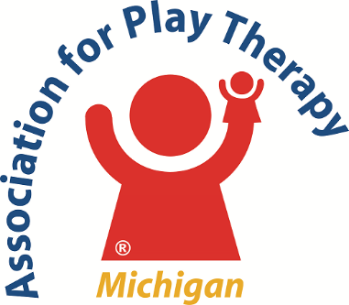
2020 Outstanding Achievement Award in Play Therapy
To be awarded at the 25th Annual MIAPT Conference in Lansing in February 2020
Purpose: To recognize a Michigan play therapist(s) who has impacted the field of play therapy through innovative or advancement in practice, training/teaching or scholarship.
Eligibility  - Mental Health Professional with a minimum of a Master’s Degree.  - Currently practicing or retired.  - Current member of APT and MIAPT.  - Member in good standing, or in good standing at retirement, of a professional association in their field (e.g. APA, ACA, NASW, ASMC, APT).  - Hold a current, or held at retirement, a MI State License/registrations/certification in their field.  Who Can Nominate  - Play Therapist  - Mental Health Professional  - Administrators  - Parents  - Teachers  - Training/teaching models | Criteria  The nominees should…  - Possess the personal qualities thought to be desirable in a play therapist.  - Demonstrate outstanding leadership skills.  - Exemplify the values and ethics of their professional discipline.  The nominee must have been responsible for innovations or advancements in play therapy that have…  - Either expanded or enhanced direct service to children and families,  - Expanded knowledge of play therapy to the profession or community, and  - Taken place within five years prior to the date of nomination.  The nominee’s achievement may be evidenced by one or more of the following…  - Community leadership  - Direct practice techniques and methods  - Published scholastic work  - Community recognition

2020 Awards Nomination Form
Name/Title of Nominee _______________________________________________________________________________
Daytime phone_____________________________ Email_____________________________________________________
Business Address _____________________________________________________________________________________ City__________________________________________ State _____________ Zip Code____________________________
Name of Person submitting Nomination __________________________________________________________________
Daytime phone_____________________________ Email_____________________________________________________
Business Address _____________________________________________________________________________________ City__________________________________________ State _____________ Zip Code____________________________
Signature _____________________________________________________________ Date ________________________
Directions: Using the award criteria as a guideline, complete this application form. Attach the following supporting documentation: 1) a letter of no more than 500 words describing the nominee’s contribution to the field(s); 2) a photo of the nominee; 3) additional letter(s) – up to three letters in support of the nomination (these can be from supervisors, administrators, parents, colleagues, students, etc.); and 4) any additional documentation such as news clips, programs, or training brochures/description review, etc. Additional supporting documentation (#4) is strongly encouraged. Submission Deadline is January 1, 2020. Email nomination form and supporting documentation to: mymiapt@gmail.com, Subject: AWARD NOMINATION
****NOMINATIONS MUST HAVE COMPLETE SUPPORTING DOCUMENTATION OF AT LEAST #1 (LETTER) & #2 (PHOTO) TO BE CONSIDERED. ADDITIONAL DOCUMENTATION IS STRONGLY ENCOURAGED.***

